**1.1 ROUND 1**

Query 1:

SELECT DISTINCT JOB FROM EMP;

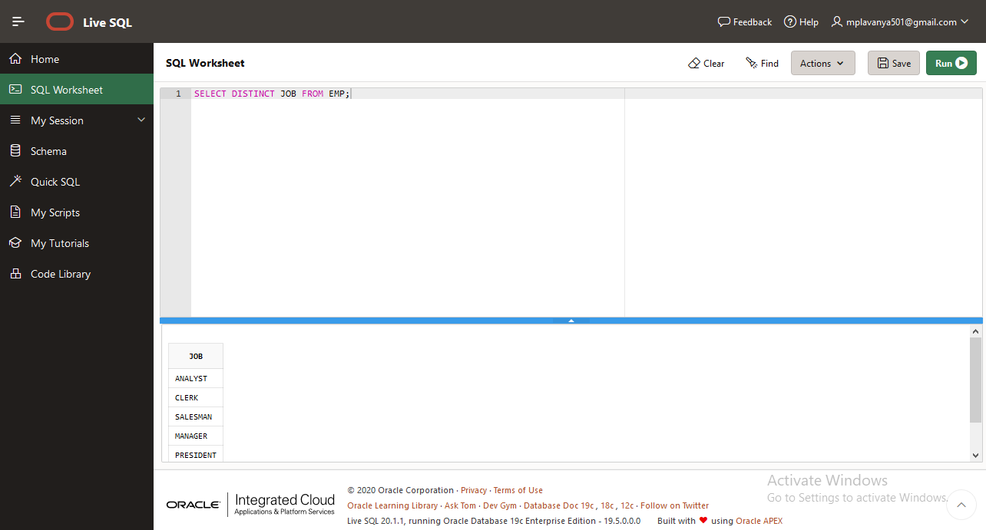

Query 2:

SELECT * FROM EMP ORDER BY SAL ASC;

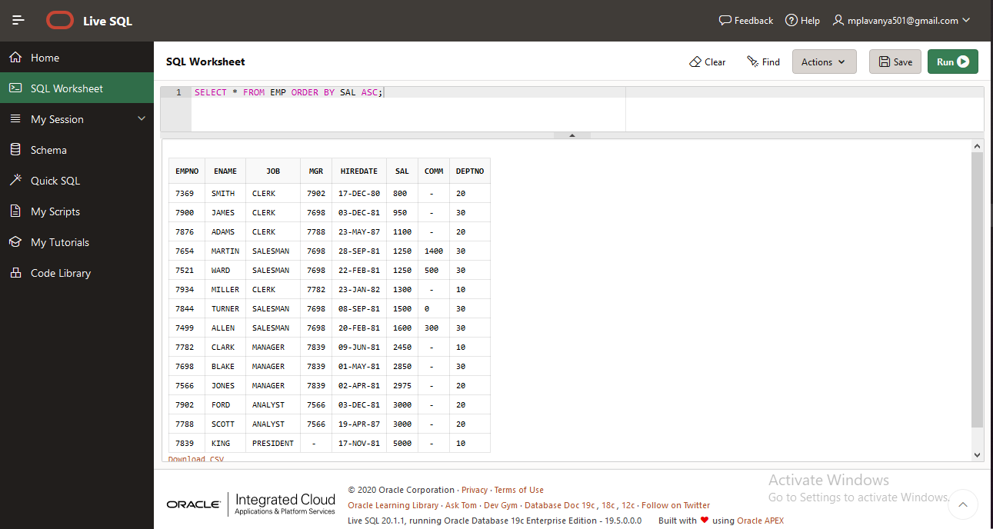

Query 3:

SELECT * FROM EMP ORDER BY DEPTNO ASC,JOB DESC;

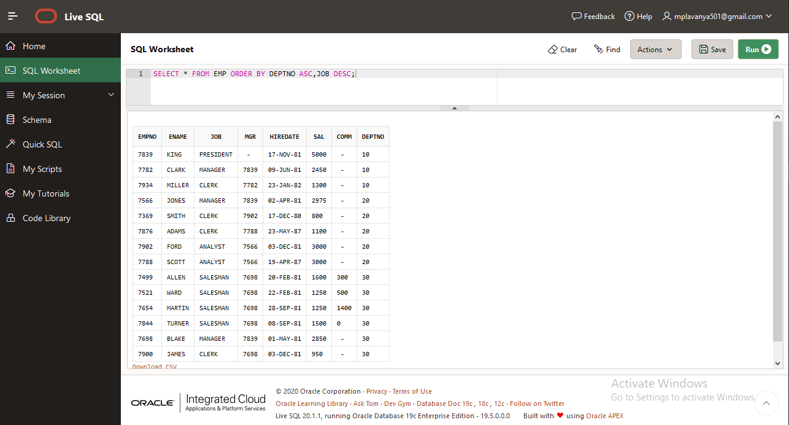

Query 4:

SELECT DISTINCT JOB FROM EMP ORDER BY JOB DESC;

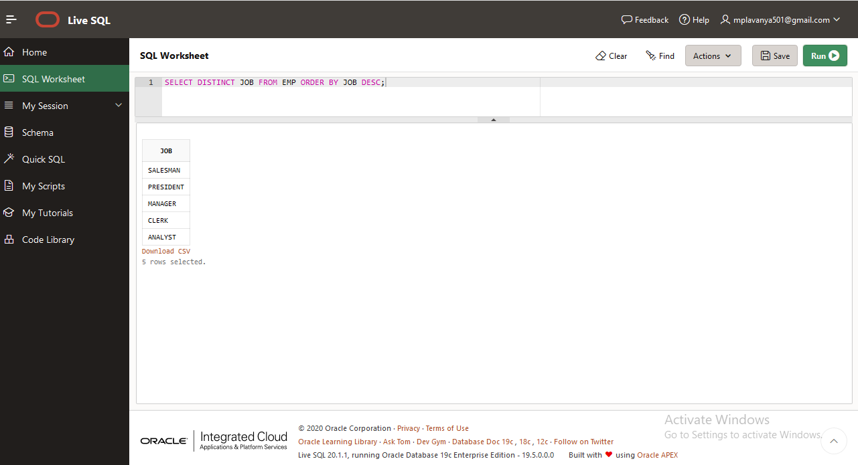

Query 5:

SELECT * FROM EMP WHERE JOB = 'MANAGER';

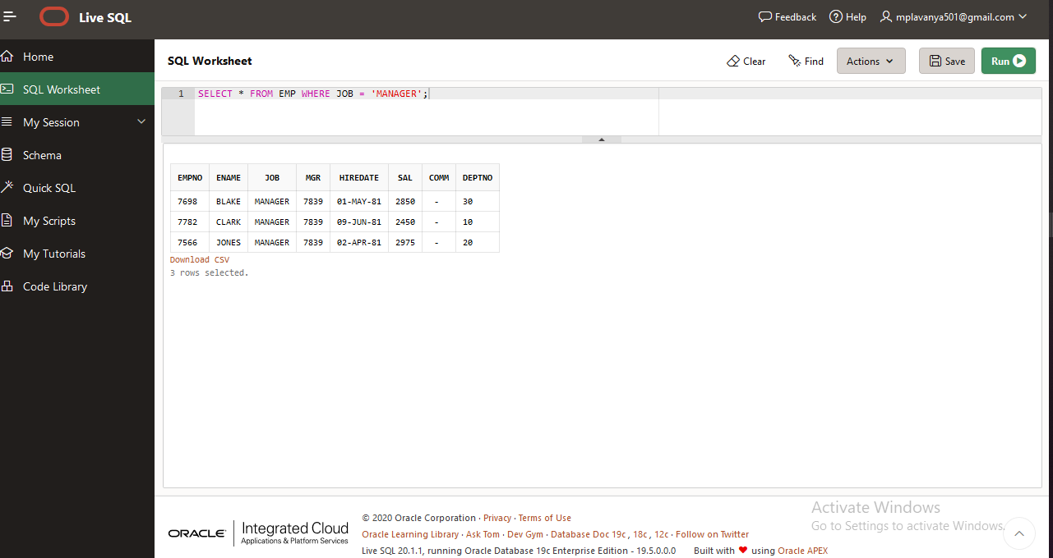

Query 6:

SELECT * FROM EMP WHERE HIREDATE < ('1-JAN-1981');

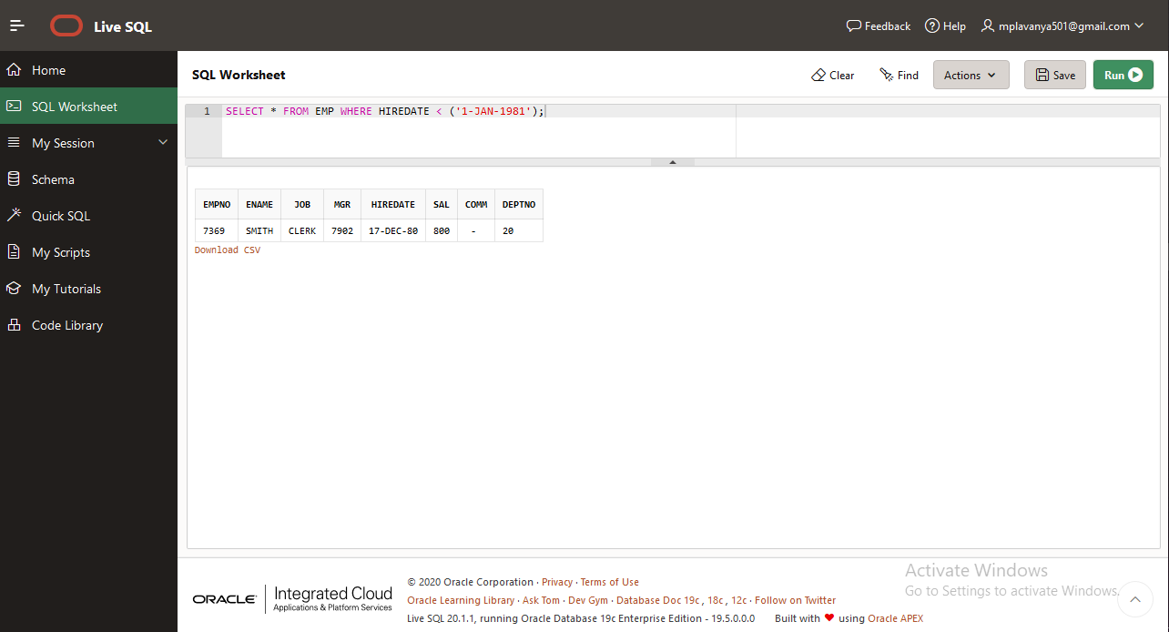

Query 7:

SELECT EMPNO,ENAME,SAL,SAL/30 AS DAILY,SAL*12 AS ANNUAL_SALARY FROM EMP ORDER BY ANNUAL_SALARY ASC;

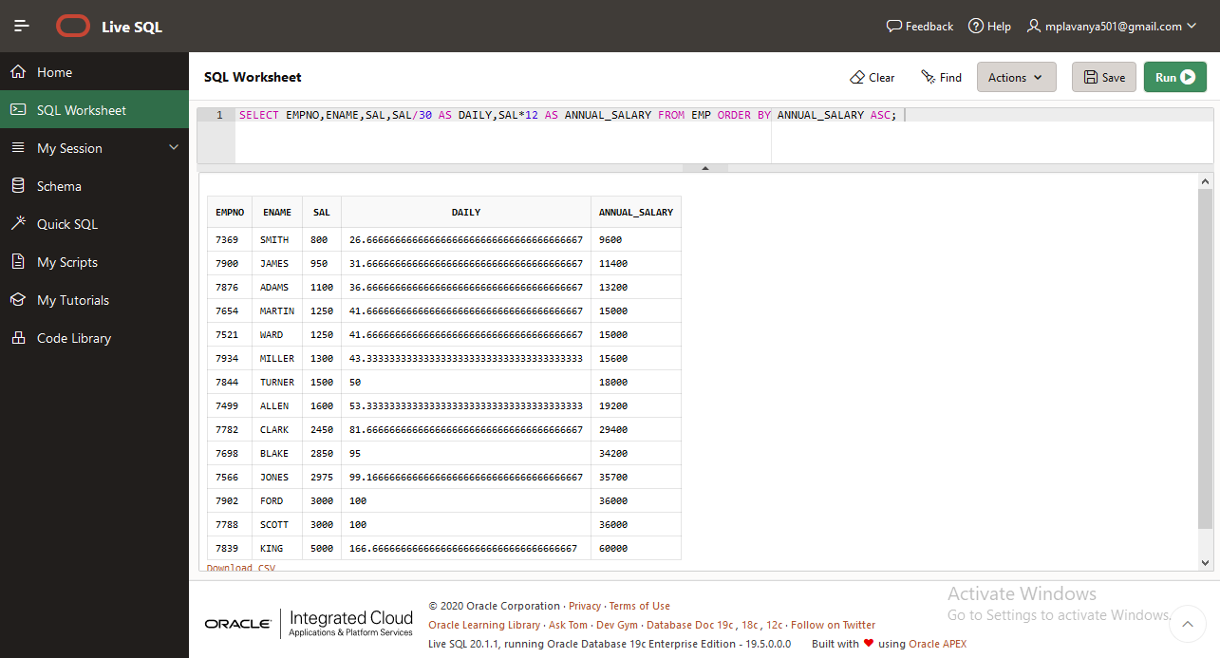

Query 8:

SELECT EMPNO,ENAME,JOB,HIREDATE,MONTHS_BETWEEN(SYSDATE,HIREDATE)/12 EXP FROM EMP WHERE JOB='MANAGER';

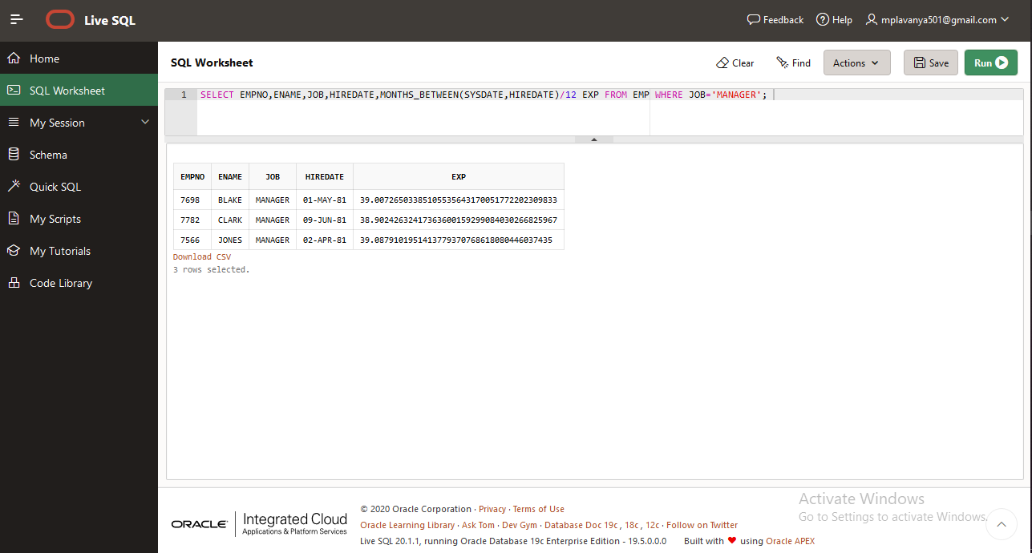

Query9:

SELECT EMPNO,ENAME,SAL,MONTHS_BETWEEN(SYSDATE,HIREDATE)/12 EXP FROM EMP WHERE MGR='7369';

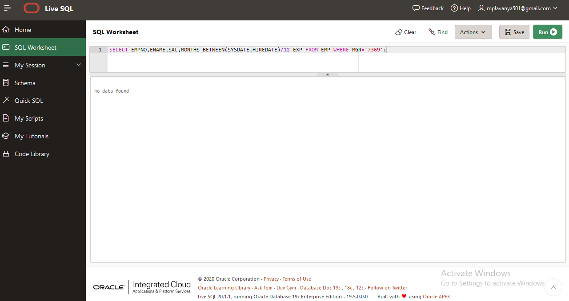

Query 10:

SELECT * FROM EMP WHERE COMM>SAL;

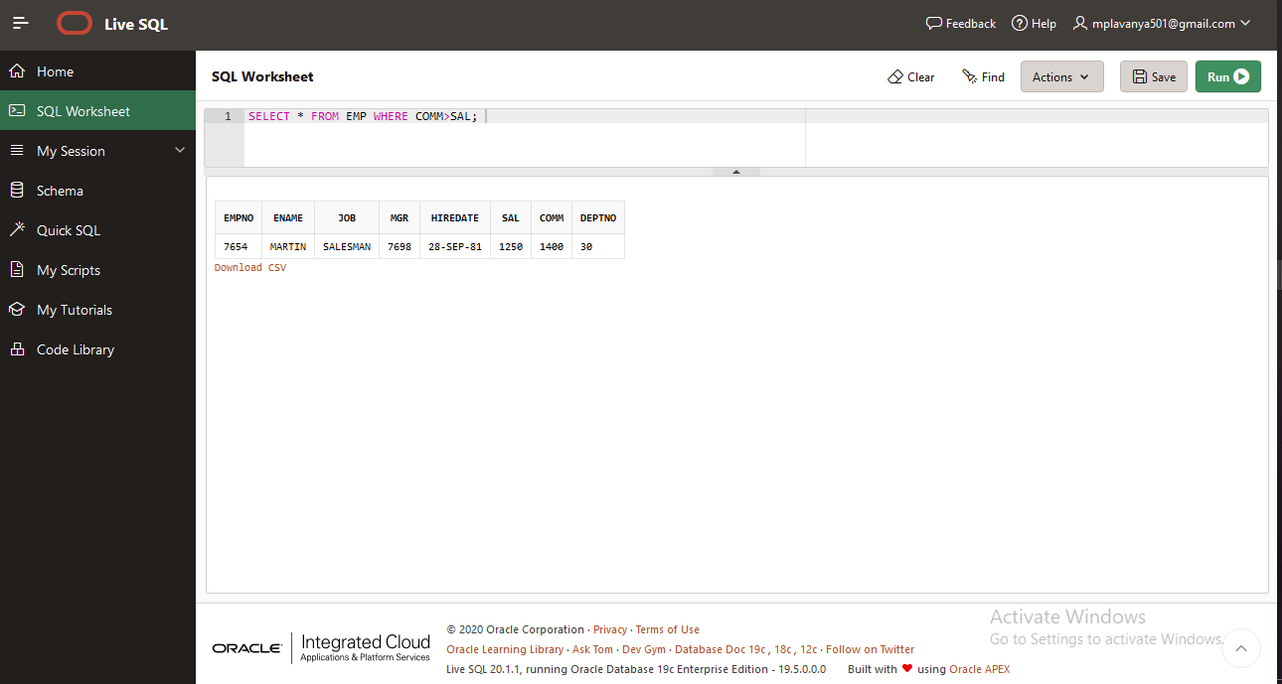

Query 11:

SELECT * FROM EMP WHERE HIREDATE > ('30-JUN-1981') ORDER BY JOB ASC;

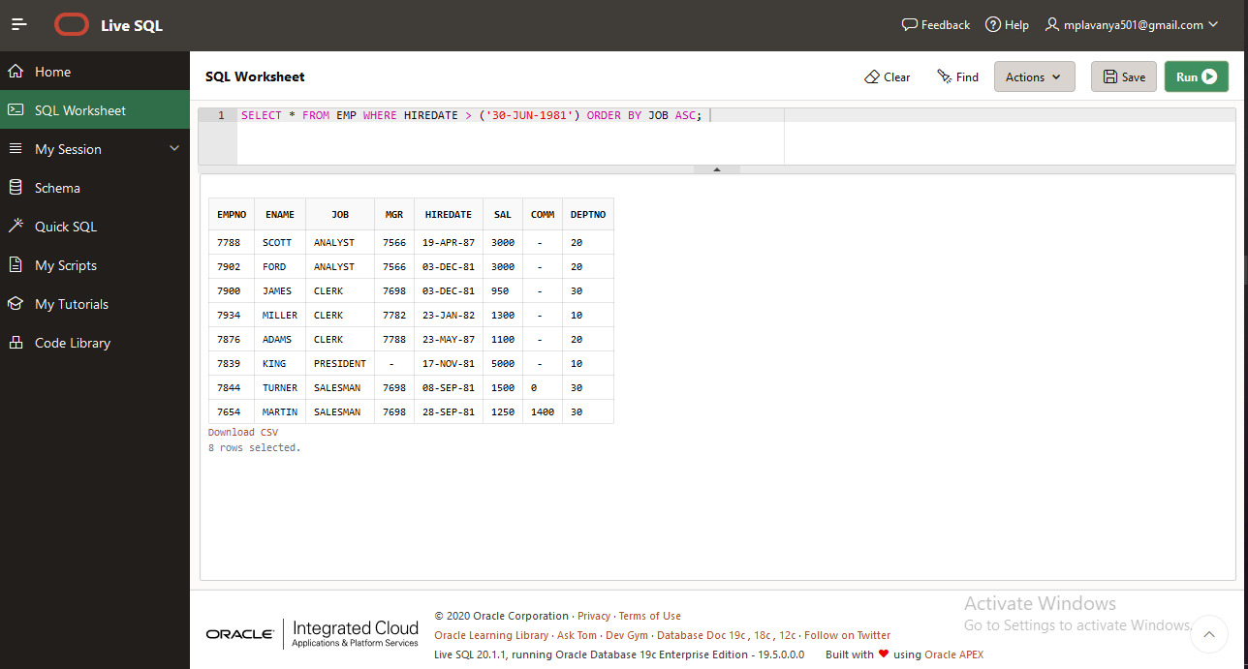

Query 12:

SELECT EMPNO,ENAME,JOB,MGR,HIREDATE,SAL,COMM,DEPTNO,MONTHS_BETWEEN(SYSDATE,HIREDATE)/12 EXP FROM EMP WHERE SAL/365 > 100;

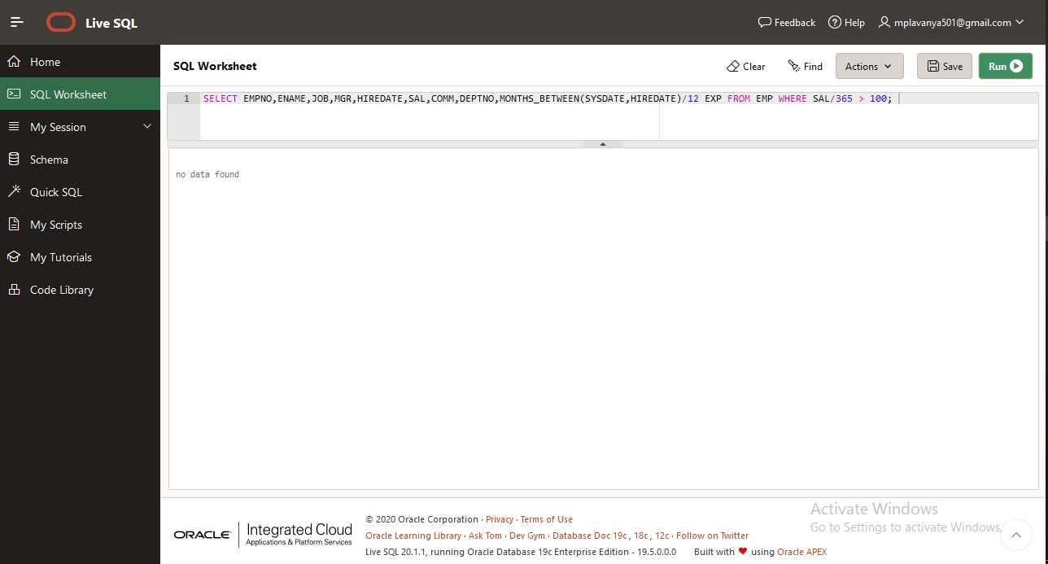

Query 13:

SELECT * FROM EMP WHERE JOB IN ('CLERK','ANALYST') ORDER BY JOB DESC;

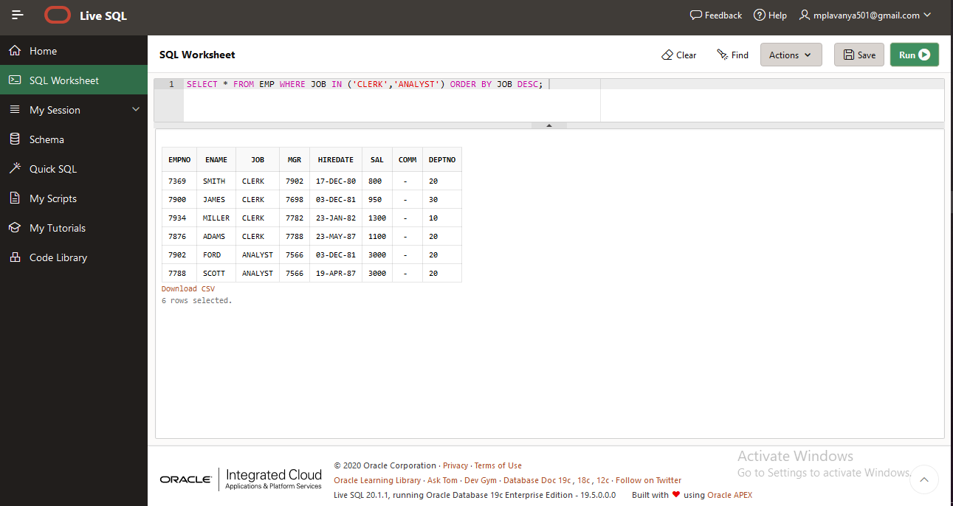

Query 14:

SELECT EMPNO,ENAME,JOB,MGR,HIREDATE,SAL,COMM,DEPTNO,MONTHS_BETWEEN(SYSDATE,HIREDATE)/12 EXP FROM EMP WHERE HIREDATE IN ('1-MAY-81','3-DEC-81','17-DEC-81','19-JAN-80') ORDER BY HIREDATE ASC;

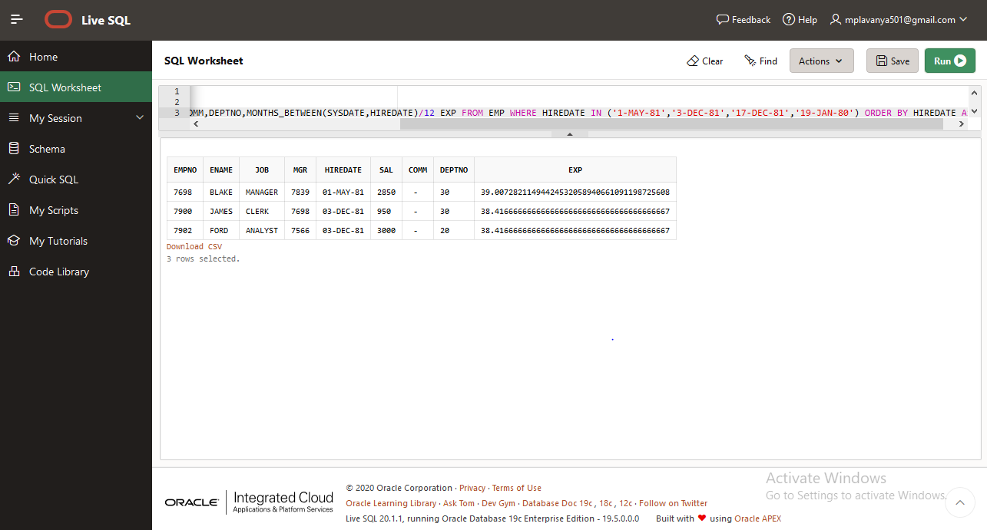

Query 15:

SELECT * FROM EMP WHERE DEPTNO IN ('10','20');

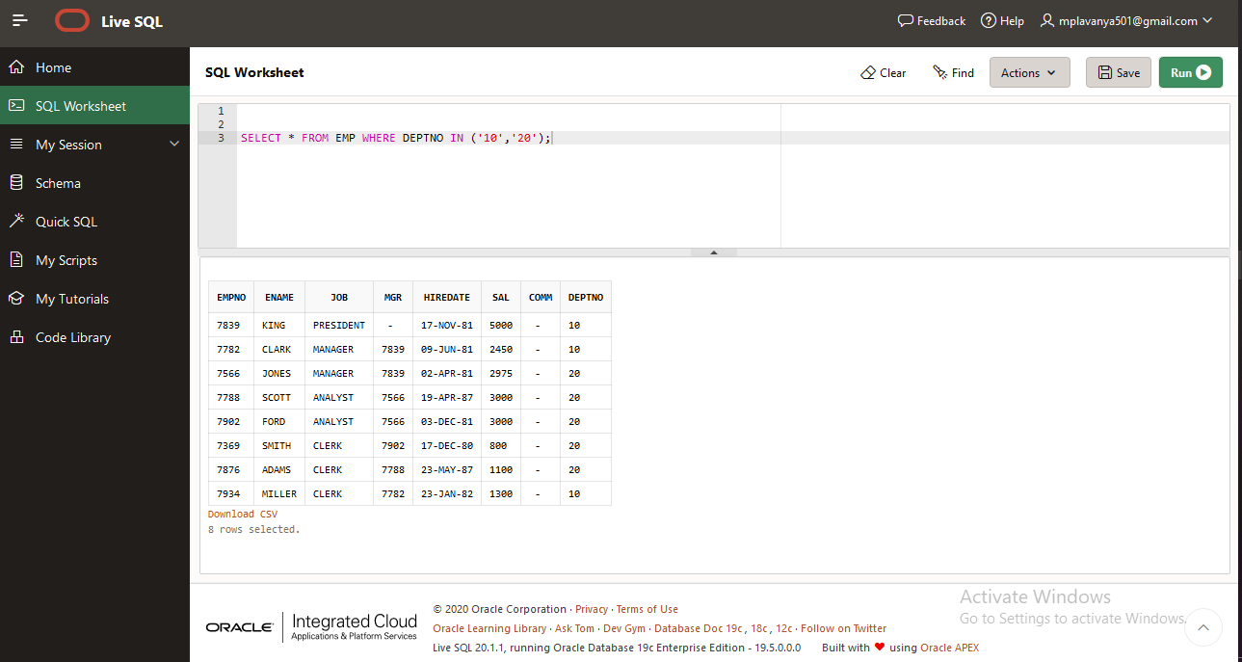

Query 16:

SELECT * FROM EMP WHERE HIREDATE BETWEEN '01-JAN-1981' AND '31-DEC-1981';

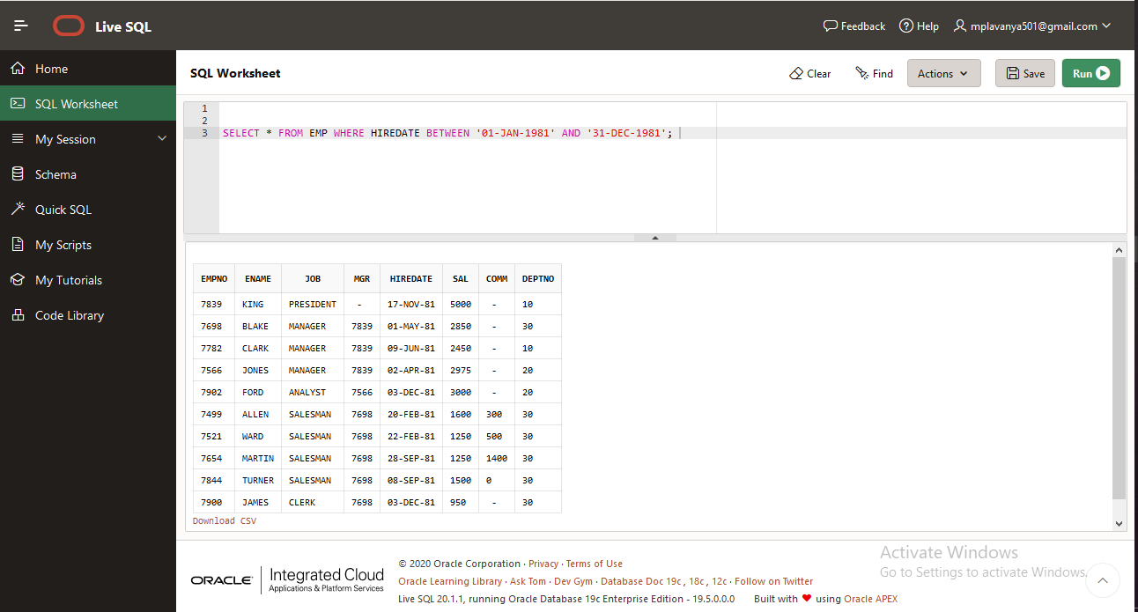

Query 17:

SELECT * FROM EMP WHERE HIREDATE BETWEEN '01-AUG-1980' AND '31-AUG-1980';

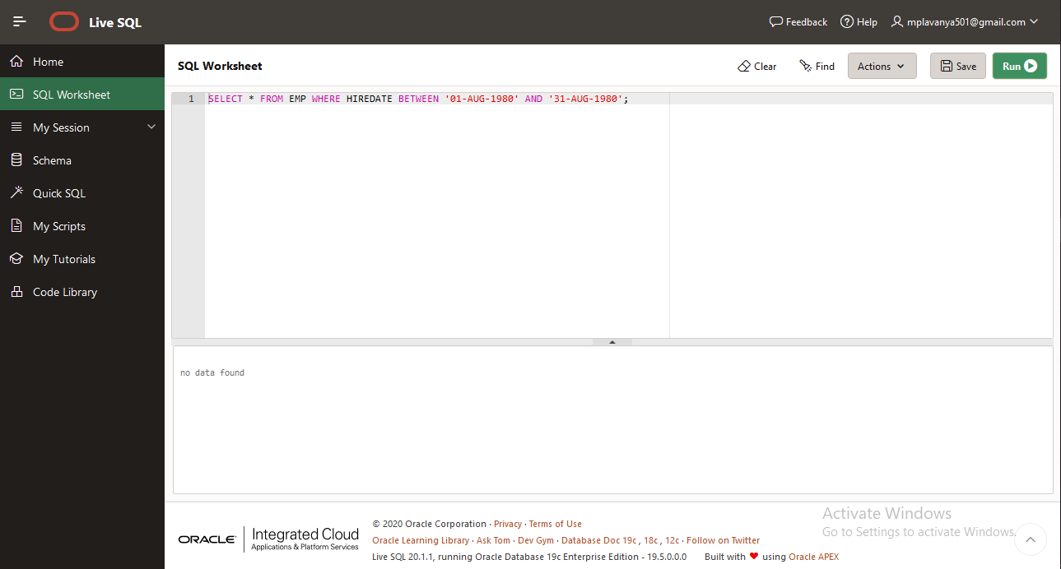

Query 18:

SELECT ENAME FROM EMP WHERE LENGTH(ENAME)=5;

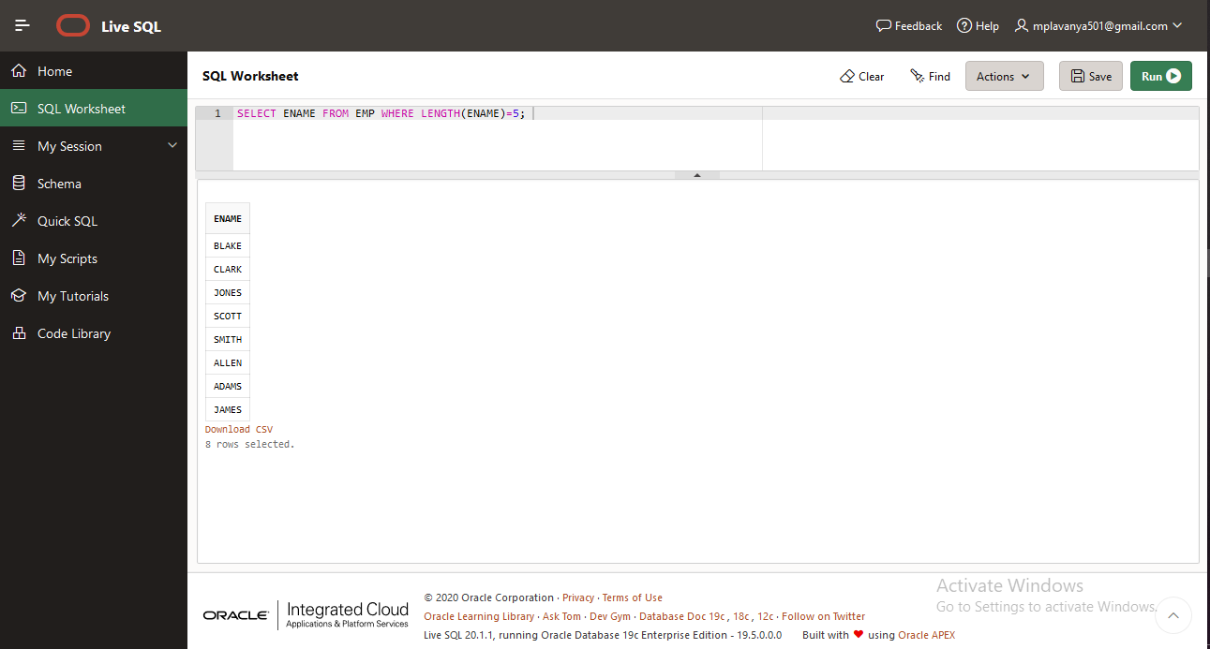

Query 19:

SELECT ENAME FROM EMP WHERE LENGTH(ENAME)=5 AND ENAME LIKE 'S%';

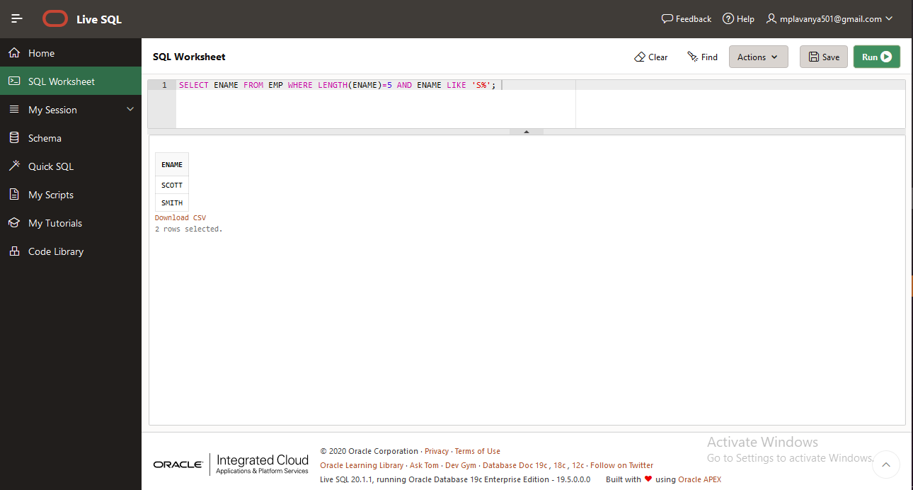

Query 20:

SELECT ENAME FROM EMP WHERE LENGTH(ENAME)=4 AND ENAME LIKE'__R%';

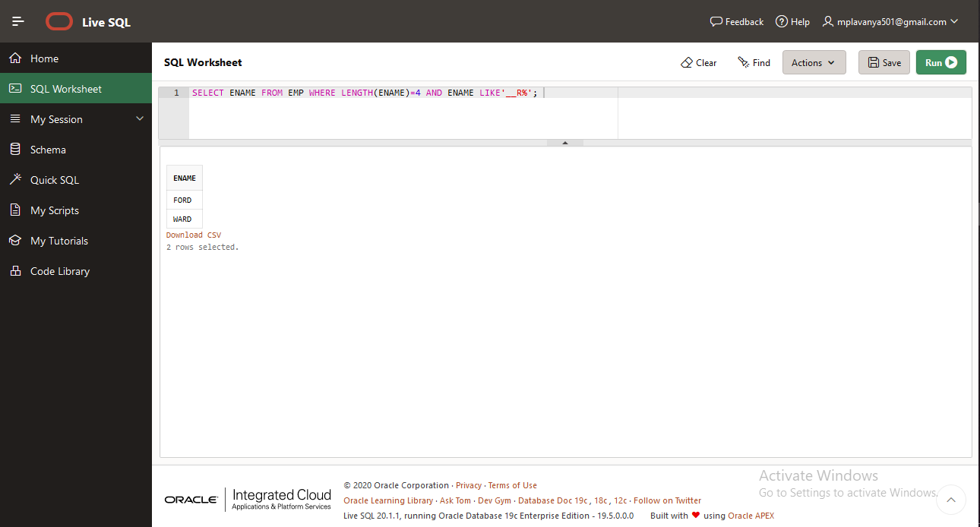

Query 21:

SELECT * FROM EMP WHERE EMPNO IN (7369, 7521, 7839, 7934, 7788);

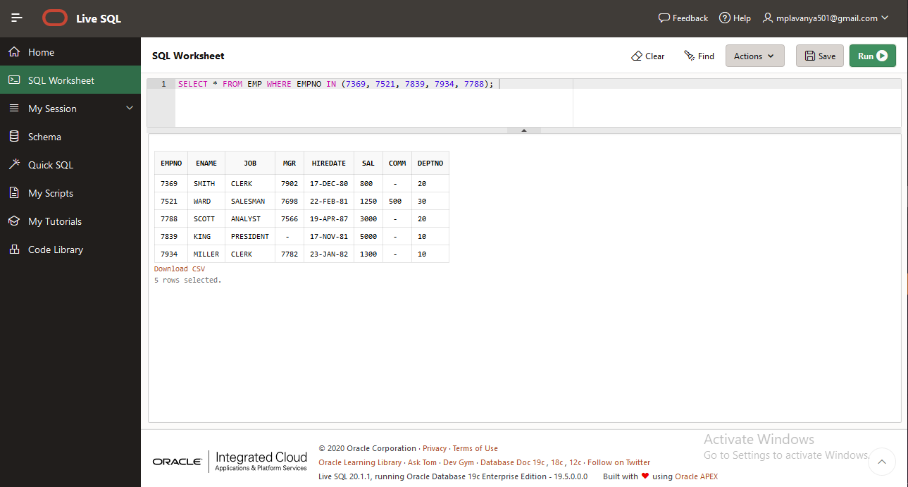

Query 22:

SELECT * FROM EMP WHERE DEPTNO NOT IN (10,30,40);

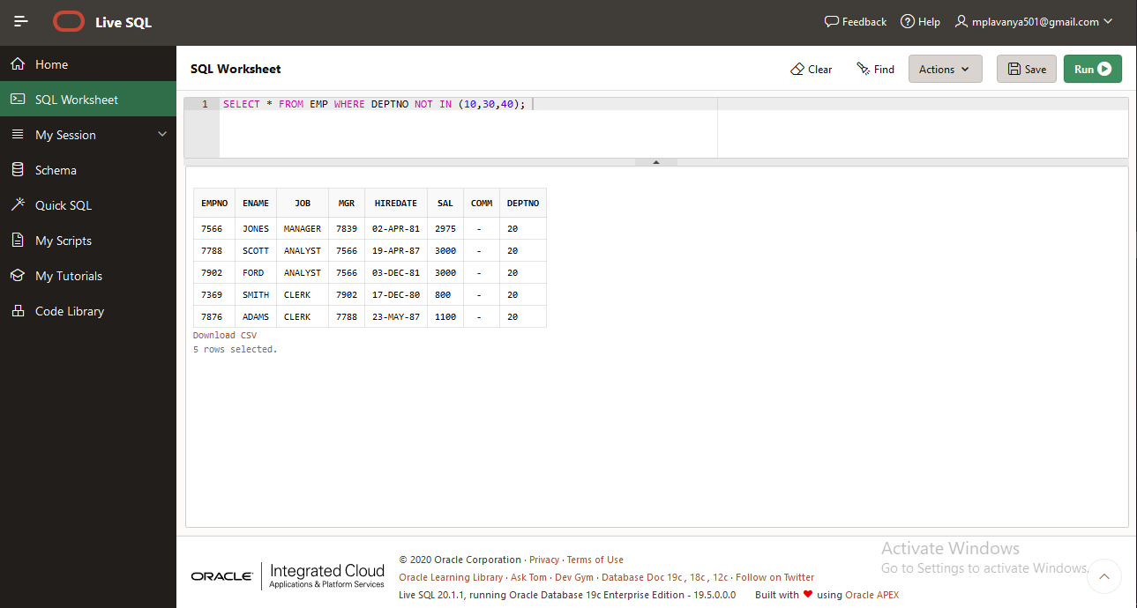

Query 23:

SELECT ENAME FROM EMP WHERE HIREDATE BETWEEN '30-JUN-1981' AND '31-DEC-1981';

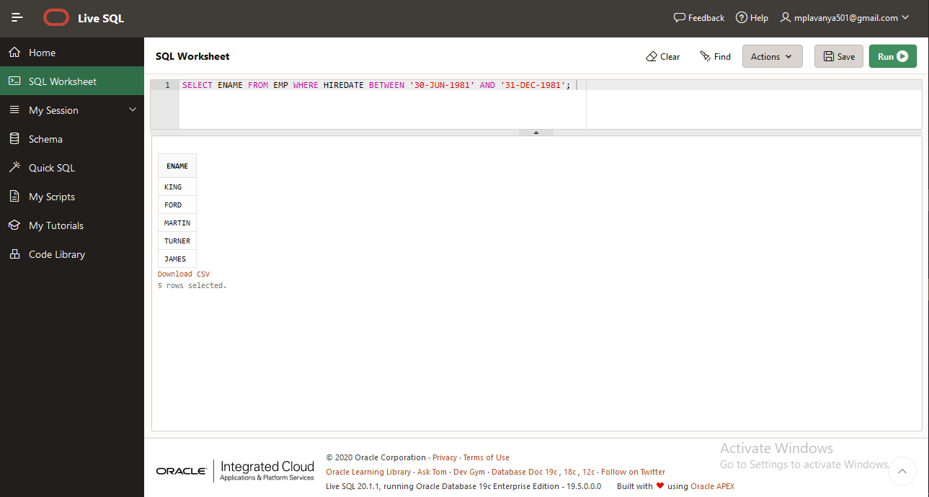

Query 24:

SELECT UNIQUE JOB FROM EMP;

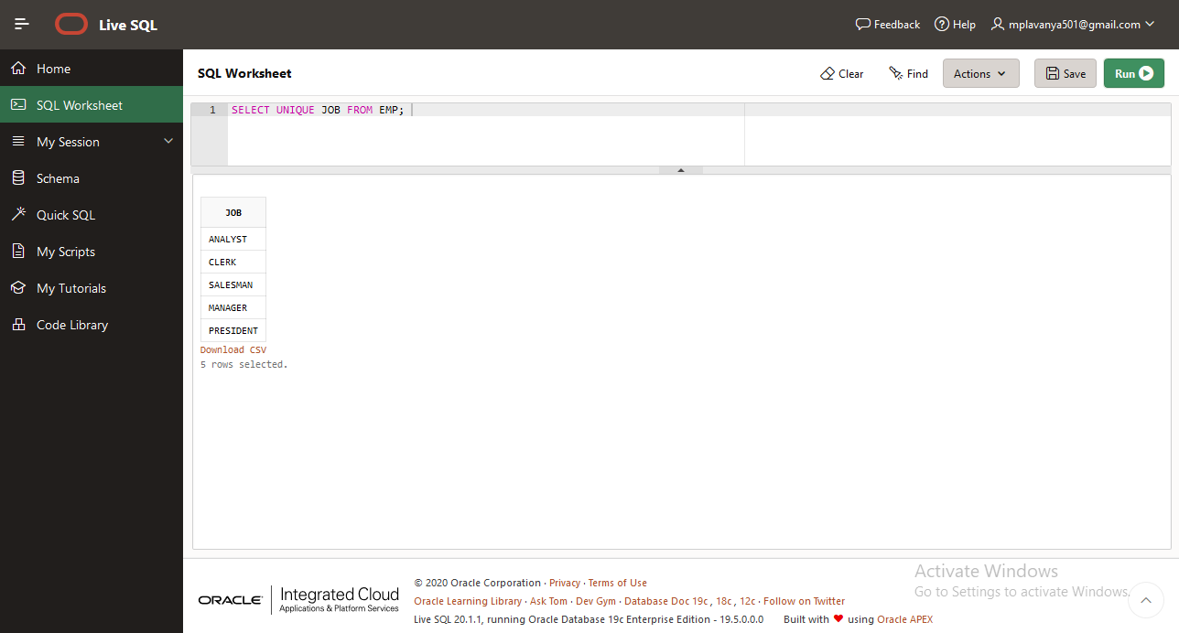

Query 25:

SELECT ENAME FROM EMP WHERE COMM IS NULL;

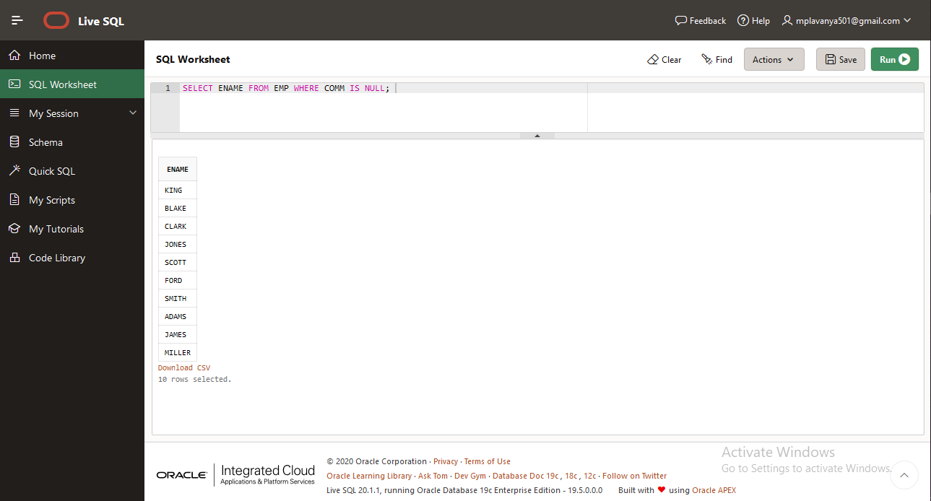

Query 26:

SELECT ENAME,JOB FROM EMP WHERE MGR IS NULL;

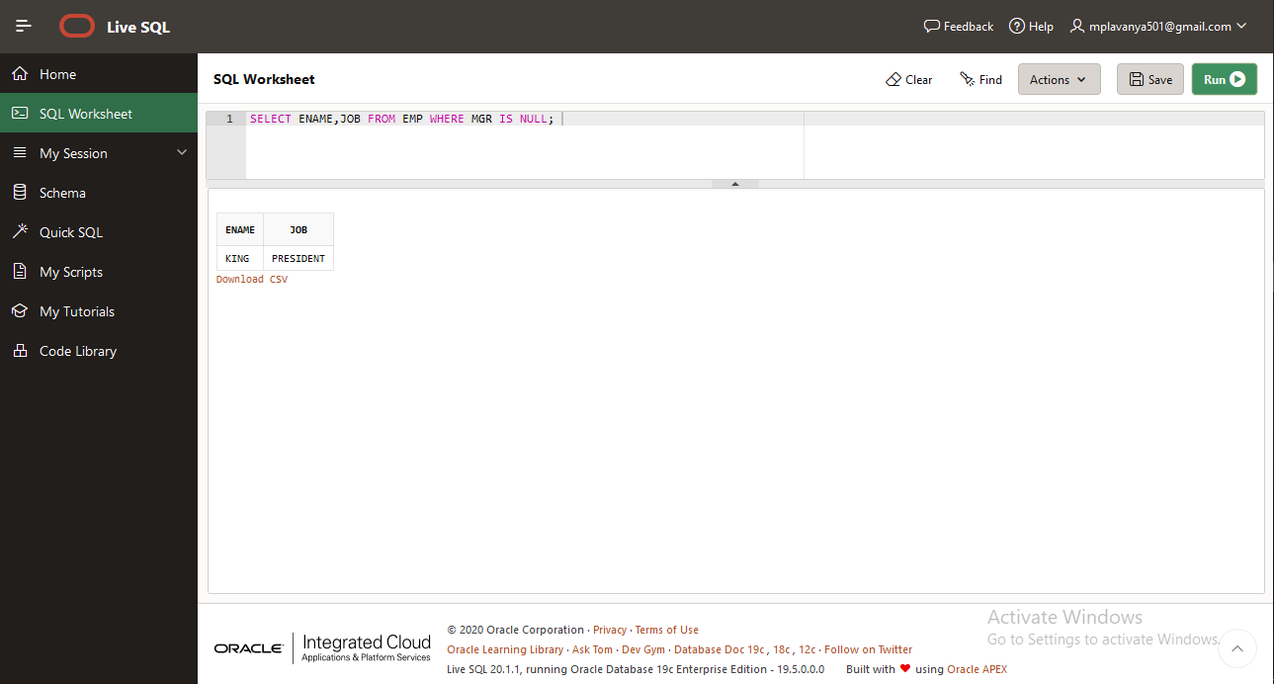

Query 27:

SELECT ENAME FROM EMP WHERE COMM IS NOT NULL;

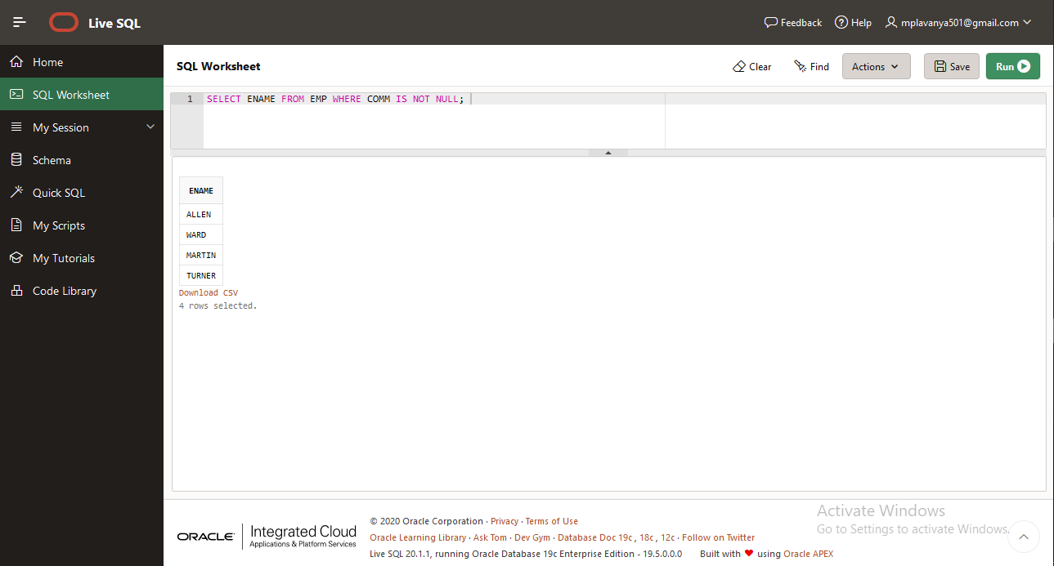

Query 28:

SELECT ENAME FROM EMP WHERE ENAME LIKE'_I%';

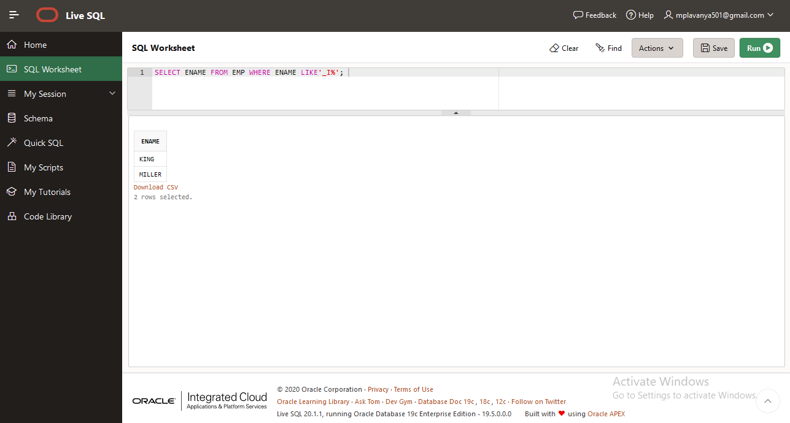

Query 29:

SELECT ENAME,SAL,NVL(COMM,0)AS COMM FROM EMP;

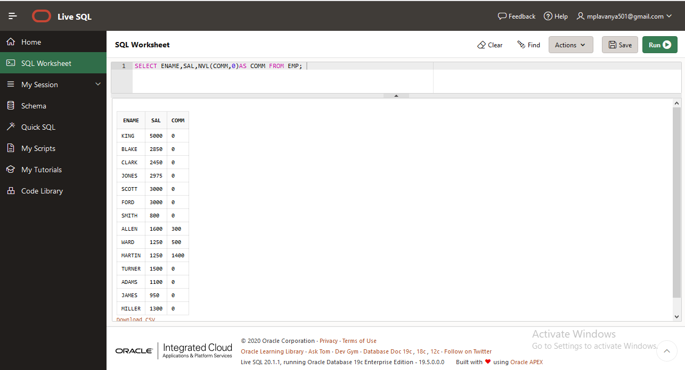

**1.2 ROUND 2**

Query1 :

SELECT COUNT(SAL) AS COUNT,AVG(SAL) AS AVERAGE FROM EMP WHERE DEPTNO = 20;

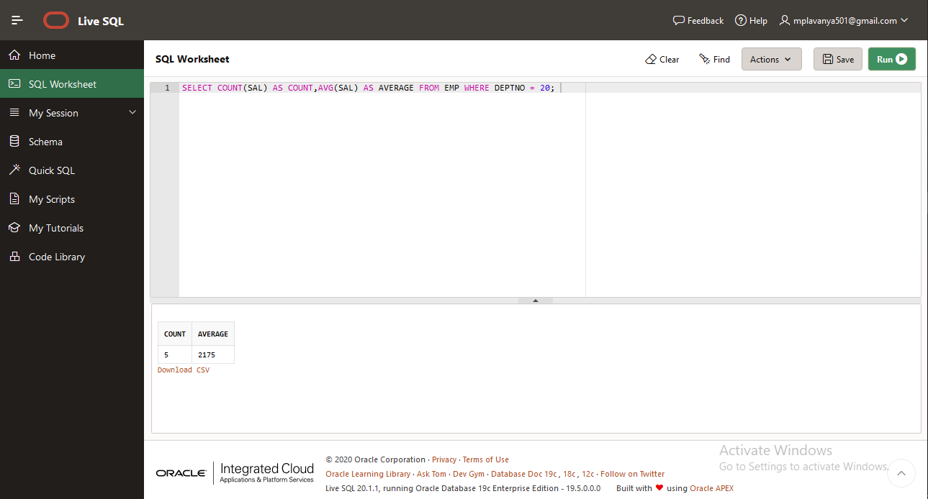

Query 2:

SELECT EMPNO,ENAME,JOB,MGR,HIREDATE,SAL,COMM,DEPTNO FROM EMP WHERE ROUND(MONTHS_BETWEEN(SYSDATE,HIREDATE)/12)>30;

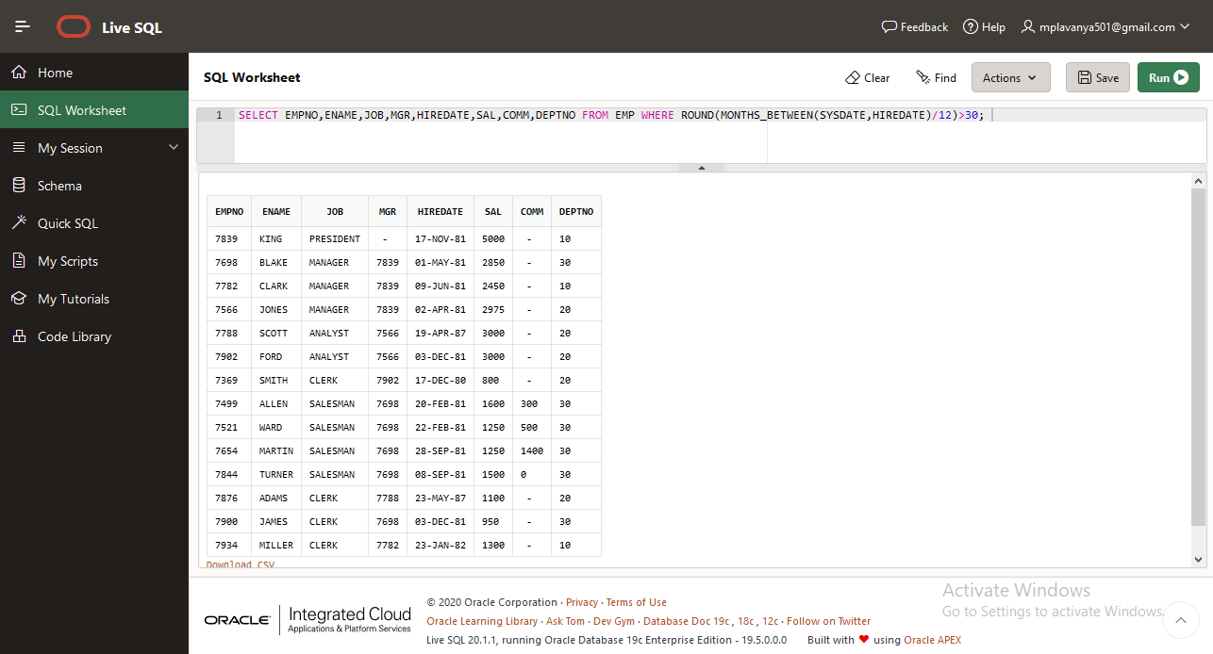

Query 3:

SELECT ENAME,HIREDATE FROM EMP ORDER BY HIREDATE DESC;

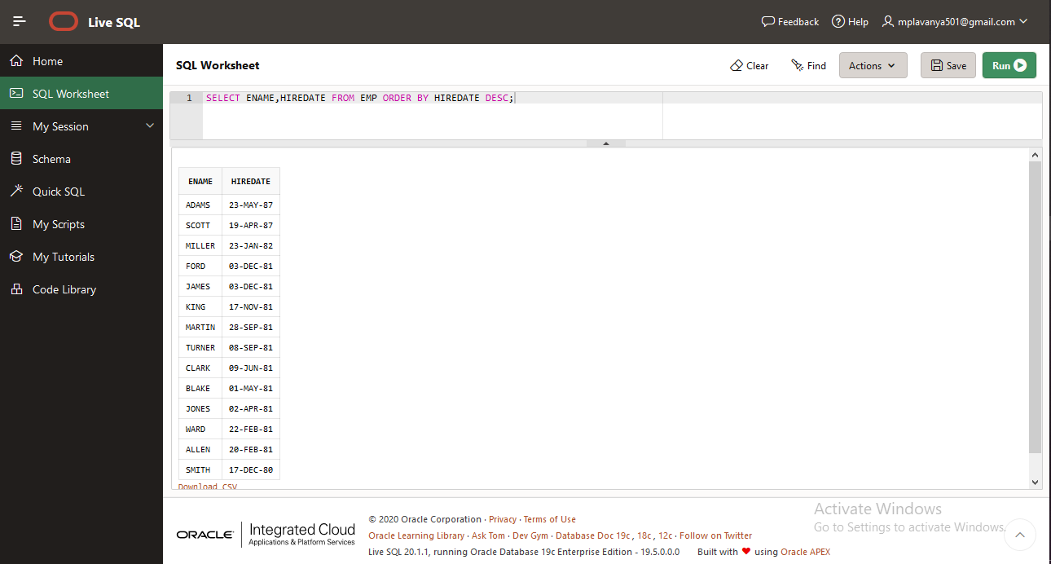

Query 4:

SELECT ENAME,SAL,SAL*15/100 AS PF,SAL*50/100 AS HRA,SAL*30/100 AS DA,SAL*12 AS GROSS FROM EMP ORDER BY GROSS ASC;

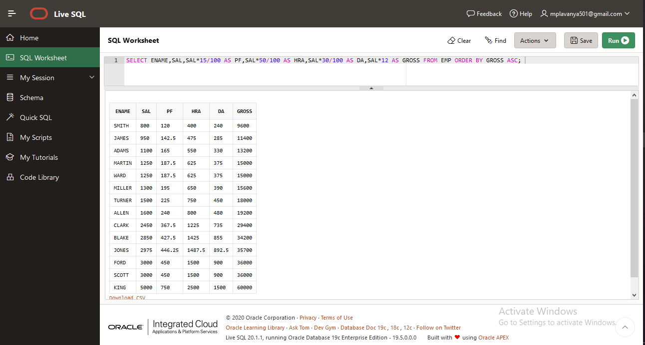

Query 5:

SELECT DEPTNO,COUNT(*) FROM EMP GROUP BY DEPTNO;

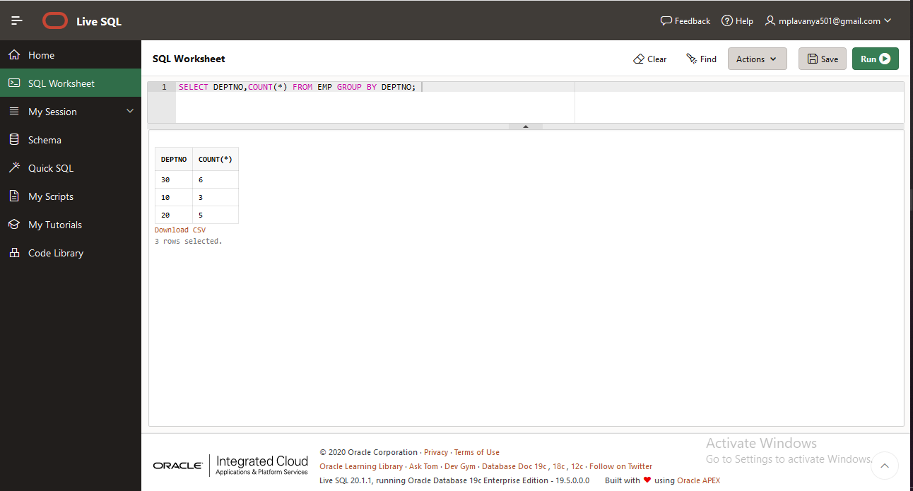

**1.3 ROUND 3**

Quer1:

SELECT * FROM EMP WHERE JOB IN (SELECT JOB FROM EMP WHERE ENAME='SMITH');

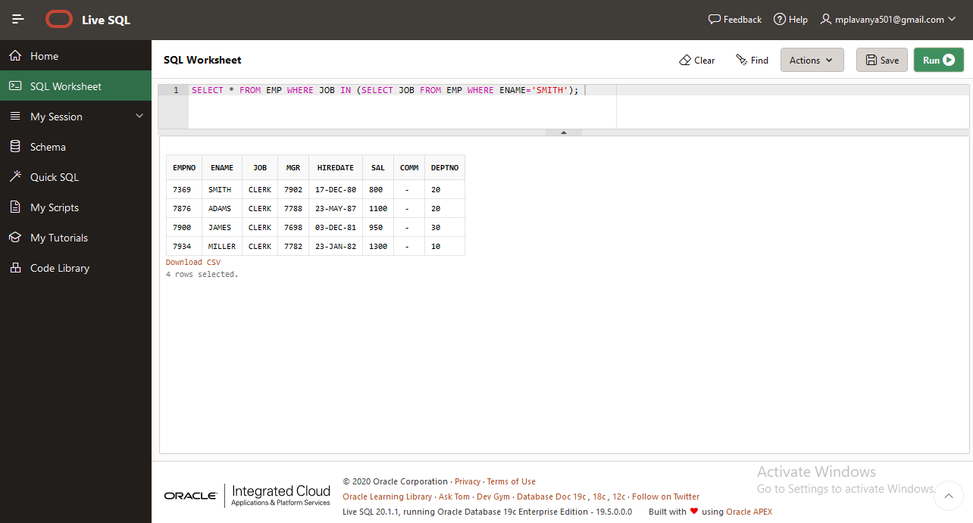

Query 2:

SELECT * FROM EMP WHERE HIREDATE > (SELECT HIREDATE FROM EMP WHERE ENAME='ADAMS');

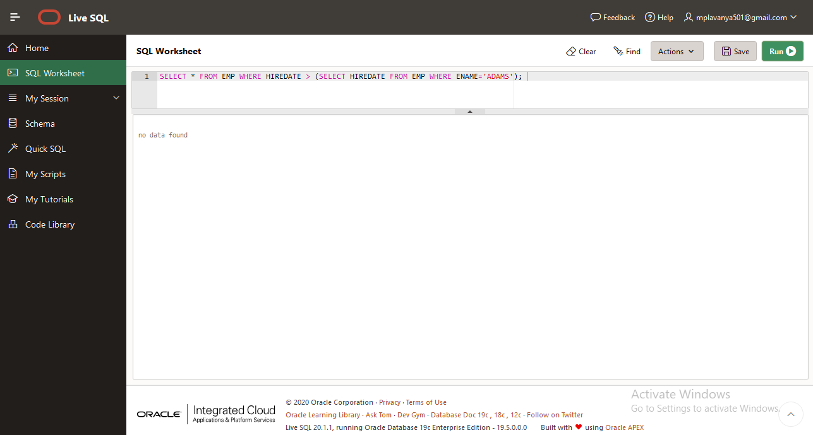query 3:

SELECT * FROM EMP WHERE SAL > (SELECT SAL FROM EMP WHERE ENAME='SCOTT');

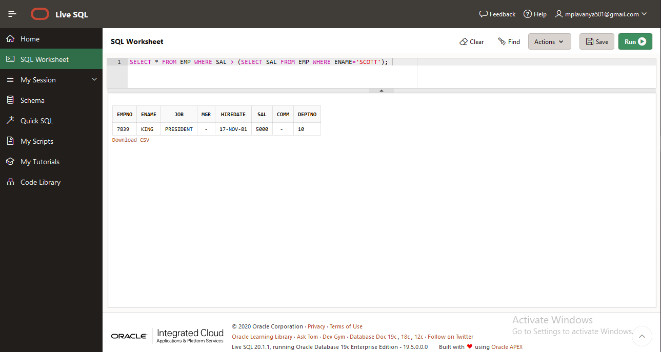

Query 4:

SELECT * FROM EMP WHERE SAL IN (SELECT MAX(SAL) FROM EMP);

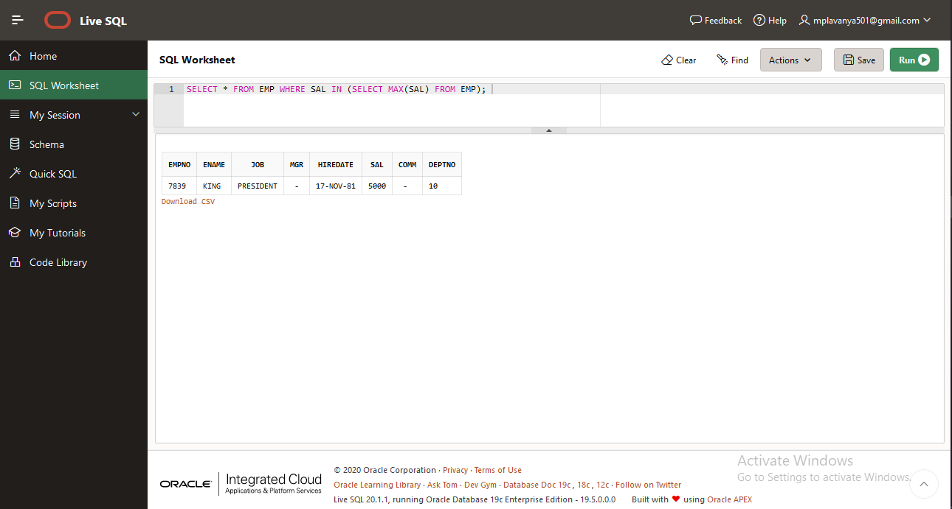

Query 5:

SELECT * FROM EMP WHERE SAL > (SELECT MAX(SAL) FROM EMP WHERE DEPTNO='30');

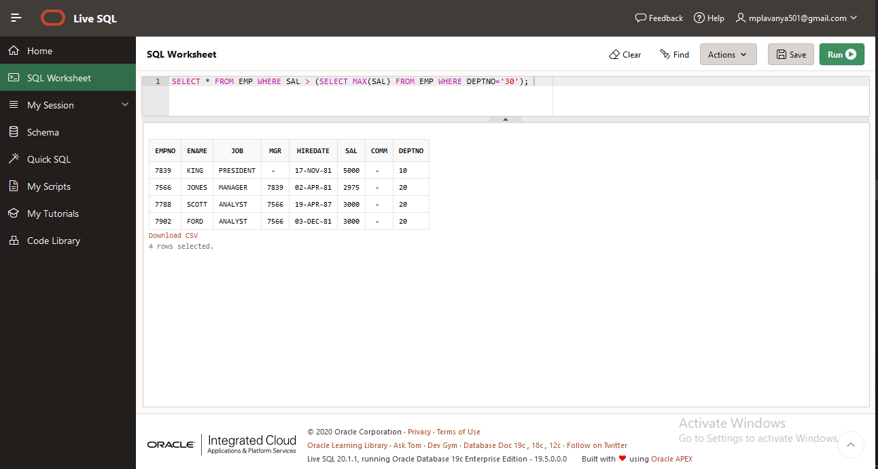

**1.4 ROUND 4**

Query 1:

SELECT E.EMPNO,E.ENAME,E.DEPTNO,D.DNAME FROM EMP E,DEPT D WHERE E.DEPTNO=D.DEPTNO;

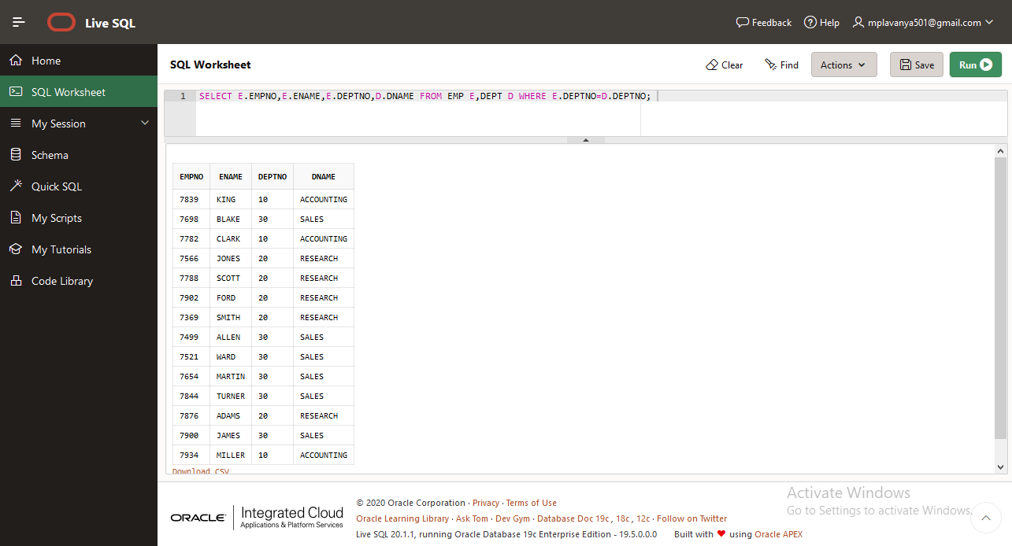

Query 2:

SELECT ENAME,MGR FROM EMP;

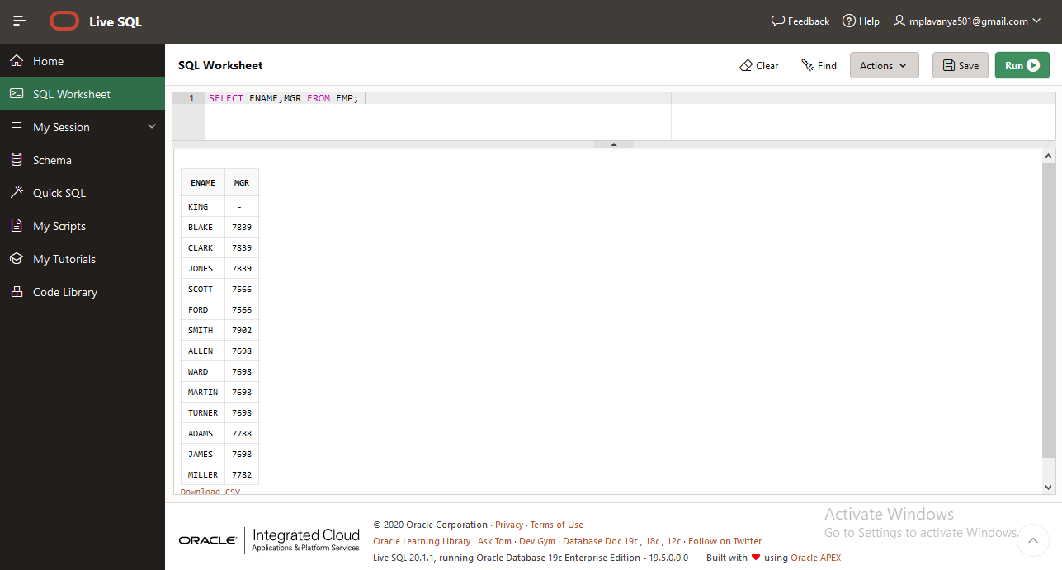

Query 3:

SELECT E.EMPNO,E.ENAME,E.JOB,E.MGR,E.SAL,E.COMM,D.DEPTNO FROM EMP E,DEPT D WHERE D.DNAME='RESEARCH' AND E.DEPTNO=D.DEPTNO;

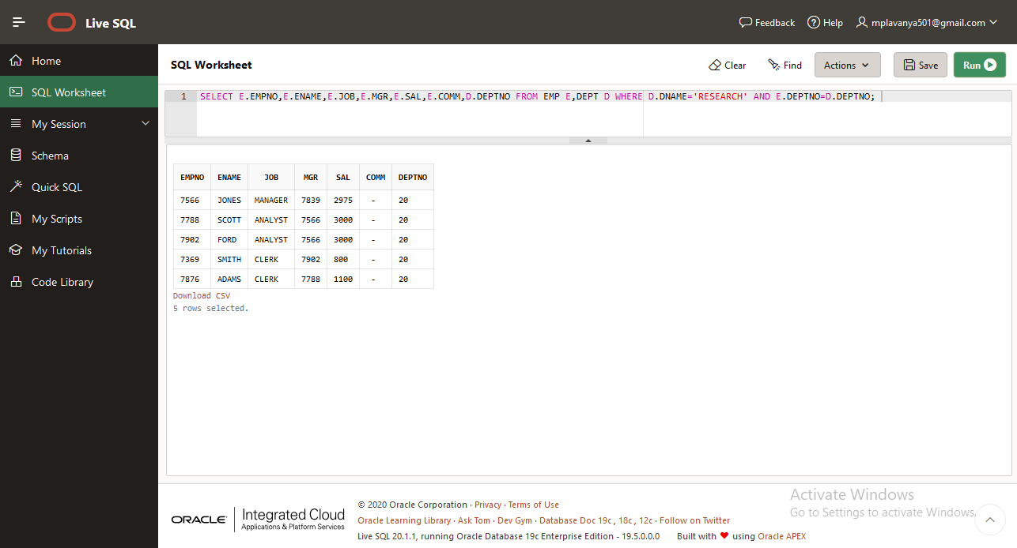

Query 4:

SELECT * FROM EMP E LEFT OUTER JOIN DEPT D ON E.DEPTNO=D.DEPTNO;

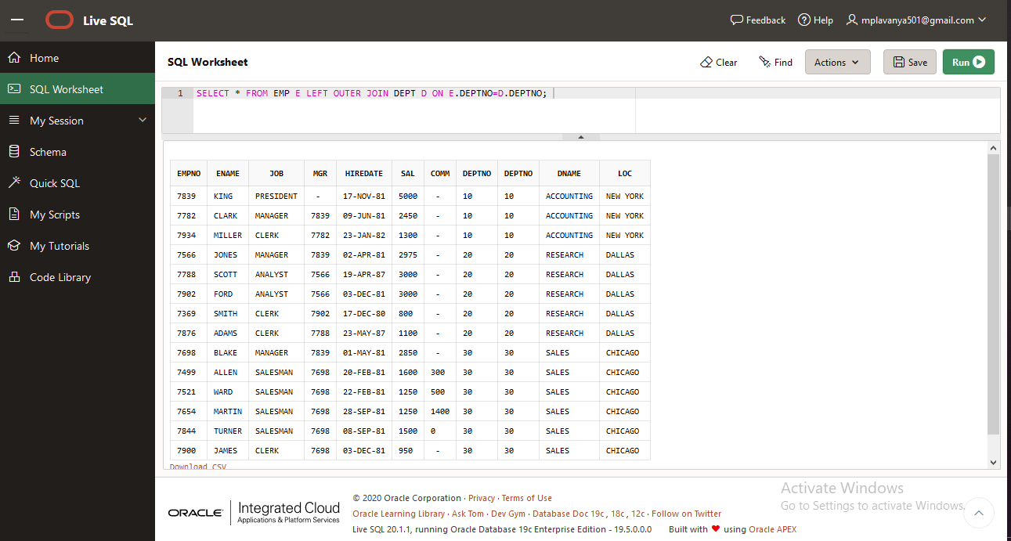

Query 5:

Same as Query 4